Project Documentation

# 1. Introduction

Project Title:Insightstream Navigate The New Landscape

Team ID: NM2025TMID28766

Team Leader: Leader Name VARSHINI D & [varshinidhanabal994@gmail.com](mailto:varshinidhanabal994@gmail.com)

Team Members:

* SOUNDARIYA S & [soundariyaselvem24@gmail.com](mailto:soundariyaselvem24@gmail.com)
* SHILA M & [sumithramahendran86@gmail.com](mailto:sumithramahendran86@gmail.com)
* MANIMOZHI R & [manimozhimanimozhi07@gmail.com](mailto:manimozhimanimozhi07@gmail.com)

# 2. Project Overview

Purpose: A React-based news application that fetches and displays the latest news articles using APIs.

Features:

* News feed with categorized sections
* Search functionality
* Responsive design with Bootstrap
* Navigation using React Router

# 3. Architecture

Frontend: React.js with Bootstrap

Backend: (Optional, if API proxy is added) Node.js + Express

Database: None (uses external news APIs)

# 4. Setup Instructions

Prerequisites: Node.js, npm, Git, Visual Studio Code

Installation Steps:

1. Clone the repository: git clone <repo-url>
2. cd news-app
3. npm install
4. npm start

# 5. Folder Structure

news-app/  
|-- public/  
|-- src/  
| |-- components/  
| |-- pages/  
| |-- App.js  
|-- package.json

# 6. Running the Application

cd news-app

npm start

Access: http://localhost:3000

# 7. API Documentation

Uses external News API (e.g., newsapi.org)

Example endpoint: https://newsapi.org/v2/top-headlines

# 8. Authentication

No authentication required for general browsing.

# 9. User Interface

Landing Page, News Categories, Search Results, Article Details Page

# 10. Testing

Manual testing in browser, Postman for API calls.

# 11. Screenshots or Demo

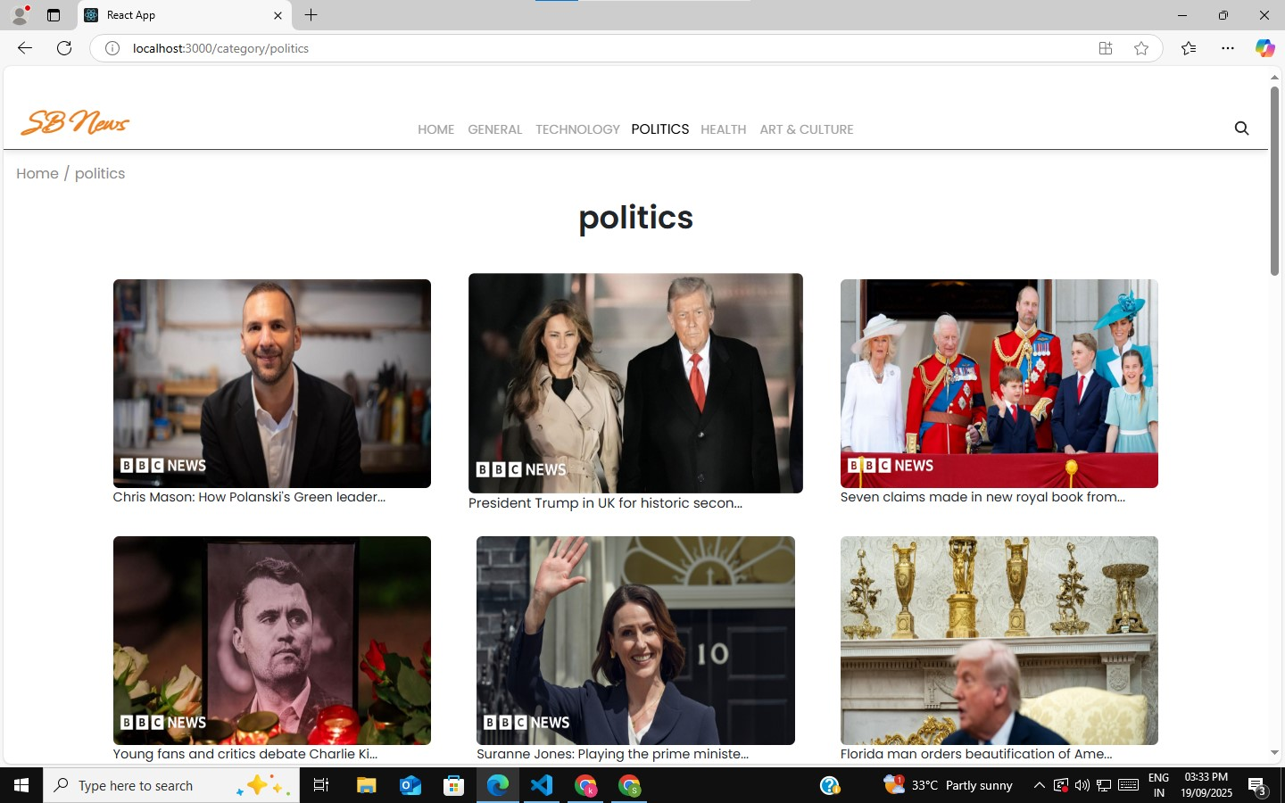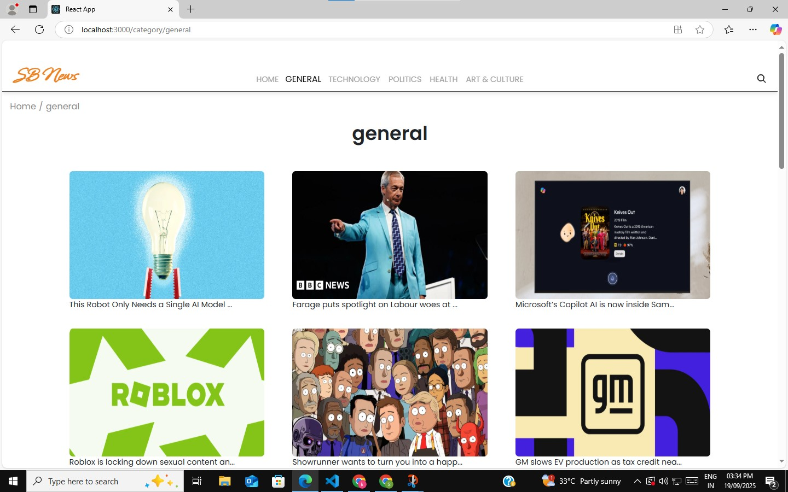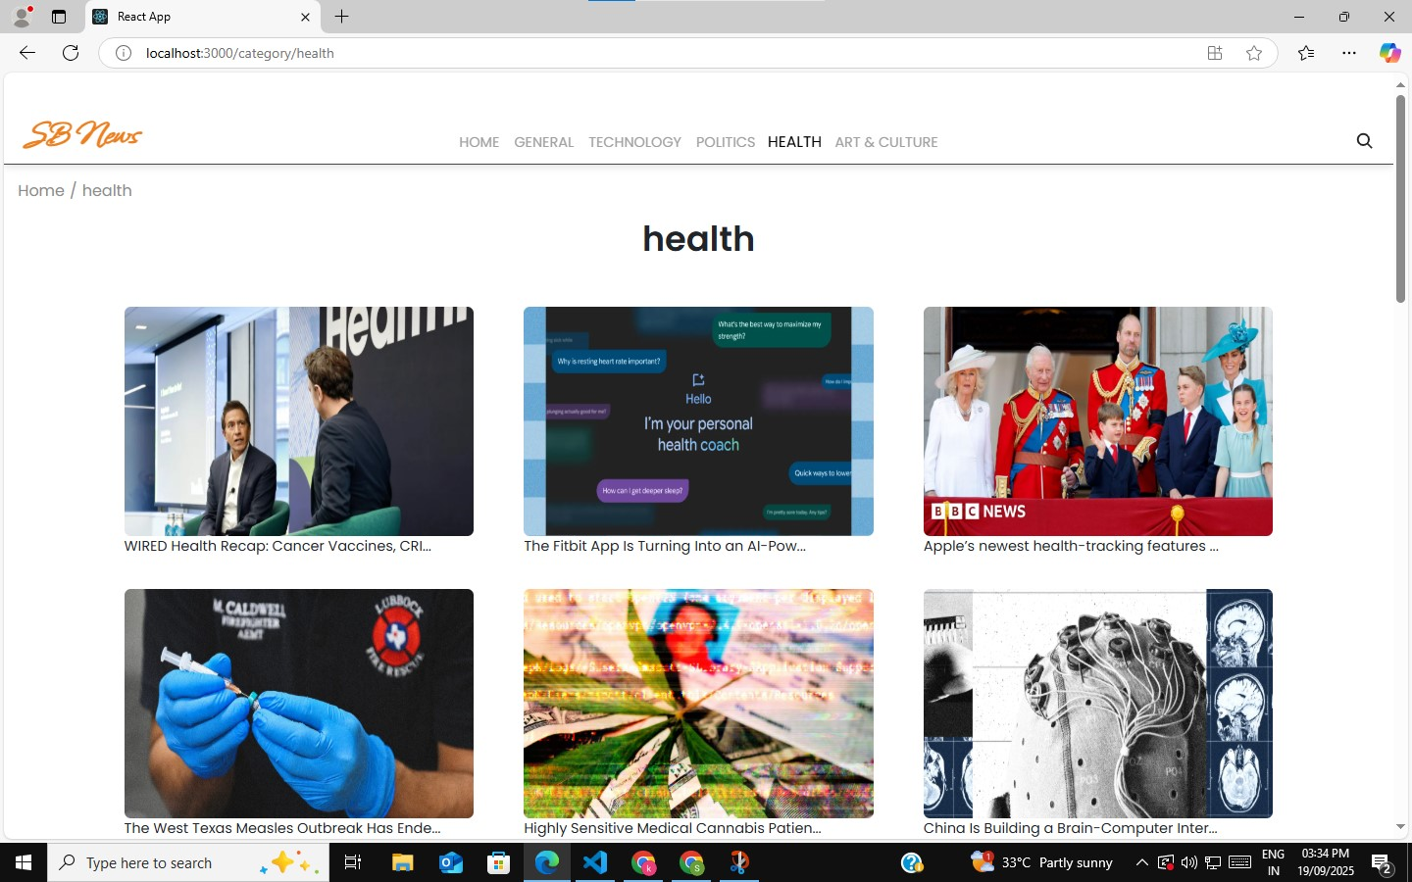

# 12. Known Issues

Currently none.

# 13. Future Enhancements

User authentication, bookmarking articles, dark mode, push notifications.